Candy Example

Molly Caldwell

2022-10-12

# Candy votes

A table example:

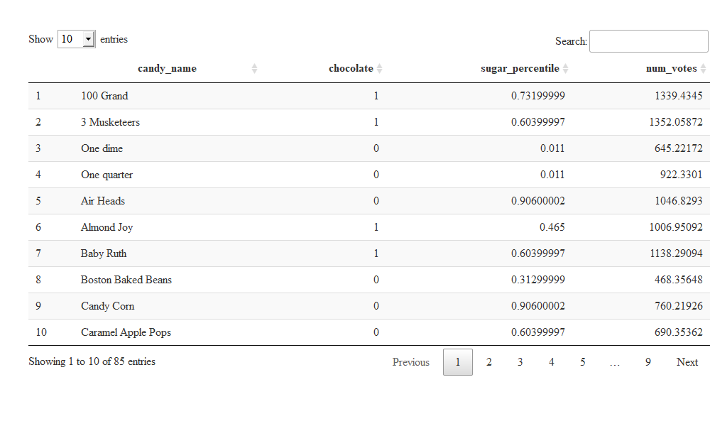

# Analysis

I’m using a linear regression to test how candy traits correspond to voters’ preference.

I tested the response of votes per candy type against the predictor variables chocolate and sugar percentile.

Linear regression formula

$$num.votes=B_{0}+B_{1}*chocolate+B_{2}*sugar.percentile$$

# Results

Summary Statistics

| term | estimate | std.error | statistic | p.value |
| --- | --- | --- | --- | --- |
| (Intercept) | 765.2423 | 51.04860 | 14.990465 | 0.0000000 |
| chocolate | 365.4661 | 49.37982 | 7.401124 | 0.0000000 |
| sugar_percentile | 171.3324 | 87.09163 | 1.967266 | 0.0525339 |

## Chocolate effects

